# Information regarding configuration of “tturlredirector.exe” as Protocol Handler for ttstudio links accessed in Chrome to open the local TestTrack Client.

Create a local web page to open in Chrome as explained in Knowledge base article. <http://www.seapine.com/knowledgebase/index.php?View=entry&EntryID=503>

NOTE: Please be sure to follow the steps exactly.

NOTE: It seems from the replies received, when you follow Step 5 in the knowledgebase that the “External Protocol Request” dialog is not displayed and that seems to be the root of the problem.

## Problem:

On step 5 of the Knowledgebase article above, if clicking the link does not open the “External Protocol Request” dialog box, then it is most probable that Chrome has been told to “Do Nothing” when a link like this was clicked in the past and is remembering the setting.

## Resolution:

Reinstall Chrome OR manually edit Chrome’s configuration file to tell it to ask you how to handle the protocol again.

By Googling around, I was able to determine that on my machine, the location of the file was suppressing the prompt was located at:

“%APPDATA%/Local/Google/Chrome/User\ Data/Local State”

I then closed Chrome.

Per the instructions on the post I used to determine how to reset this setting, I removed the ttstudio entry in the JSON data list of excluded schemes. The post I followed was: <http://askubuntu.com/questions/465586/how-to-reset-external-protocol-handler-in-chrome> Even though this was information regarding Chrome on Linux, from the user comments, I was able to adapt the solution to a Windows environment.

I then committed the file and started Chrome.

## Additional Steps

I then reloaded the file and followed the instructions in the Knowledgebase article again, starting from step 4. See following image:

At this point, here is what was observed when I clicked the TT Studio link that had the target of ttstudio://config.

I selected the “Remember my choice for all links of this type” and then pressed the “Launch Application” button.

It showed me the desired TestTrack URL Redirector Configuration dialog.

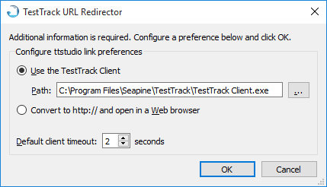

I verified it would open the client I wanted and pressed okay.

I then modified the file ttstudio.html file to make the hyperlink, “Actual ttstudio link” target a ttstudio link that would route me to a specific defect.

I reloaded the file in Chrome.

I clicked on the “Actual ttstudio link”. It launched the local client and routed me to the defect specified in the ttstudio link that I have pasted as the link target in my ttstudio.html file.